#### ONLINE TRAINING REPORT

ON

#### NETFLIX STOCK ANALYSIS

#### (DATA-ANALYSTICS)

At

#### GREAT-LEARNING

Submitted by

**SHIVANI**

**2000300130119**

In the partial fulfillment for the award of the degree of

Bachelor of Engineering in

Information & Technology

Inderprastha Engineering College, Ghaziabad UP

December, 2022

## CERTIFICATE

### **DECLARATION**

I **SHIVANI** hereby declare that I have undertaken 30-days.

Online Training Report at **Great-Learning**

during a period

from start date: **1nd October,2023** to end date : **30 October,2023** in partial fulfillment of requirements for the award of degree of B.Tech (INFORMATION TECHNOLOGY)

at

INDERPRASTHA ENGINEERING COLLEGE, GHAZIABAD

(Uttar Pradesh)

Student Signature

Student Name : **SHIVANI**

Roll No .- 2000300130119

Date : 5 December, 2023

#### Acknowledgement

The successful completion of any project requires guidance and help from a number of people. I take my immense pleasure in expressing a whole hearted thanks to all the officials who guided me all the way through my training

in the organization . I therefore take this opportunity to express my profound sense of gratitude to all those who extended their whole hearted help and support to me in carrying out the project work.

I express my deep gratitude to Great-Learning platform**,** who provided me an insight into the working that enhanced my knowledge and with their support and cooperation this report has taken a presentable form.

**SHIVANI**

#### CONTENTS

1. ABOUT NETFLIX.
2. SOFTWARE TRAINING WORK UNDERTAKEN
3. PROJECT WORK
4. RESULTS AND DISCUSSION
5. References

### **Preface**

It is well evident that work experience is an indispensable part of every professional course. In the same manner practical training in any organization is a must for a Bachelor of Engineering course. This training gives more knowledge about the real corporate world environment. It also helps the individual to improve his/her skills to a great extent and assess his/her personality in corporate life. Classroom study is quite important for gaining theoretical knowledge, but practical knowledge is equally important for the candidates to improve skills in a real working environment in any field of study.

To be a good engineer, one must be aware of the industrial environment and must know about project management, working in the industry and so on. To bridge the gap between college and the industrial environment summer training is one of the effective ways of learning. During this period, a student practices in the industry and gains experience and knowledge about working in industry.

## ABSTRACT

Since the inception of the stock market, people have been using various data models, machine learning, and data mining to predict the future movement of stock prices to make huge profits. The rise and fall of stock prices are influenced by many factors, such as political, economic, social, and market factors. For stock investors, the prediction of stock market trends is directly related to profit capture. In this paper, we use Netflix's stock price for the past ten years as the dataset for this paper. An LSTM model will be built to predict the stock price trend of NETFLIX in the next 30 days. The dataset will be divided into a training set and a test set to test the degree of fit of the data. The results show that the LSTM model is a good fit for the predicted data and the real data. Finally, Netflix's stock price for the next 30 days will be predicted using Netflix's stock price for the past 10 years, and the results show that Netflix's stock price is on an upward trend for the next 30 days.

# **ABOUT NETFLIX**

Netflix is a giant in the streaming industry, providing a vast library of movies, TV shows, documentaries, and original content to subscribers worldwide. Founded in 1997, the company initially started as a DVD-by-mail service before transitioning to a streaming model in 2007. The shift to online streaming contributed significantly to its rapid growth.

Netflix's success is not only attributed to its extensive content library but also to its focus on producing high-quality original content, known as Netflix Originals. Popular shows like "Stranger Things," "The Crown," and "Narcos" are just a few examples of their successful original productions.

The company operates on a subscription-based model, offering different plans with varying streaming quality and the number of screens allowed. It has expanded globally, making it one of the most well-known and widely used streaming services. Netflix has had a profound impact on the entertainment industry, influencing the way people consume media.

**PROJECT WORK**

Data analytics plays a crucial role in stock analysis by providing insights, patterns, and trends derived from vast amounts of financial and market data. Here's a brief overview:

**Historical Data Analysis:** Analysts use historical stock prices, trading volumes, and other financial metrics to identify patterns and trends. This helps in making informed predictions about future price movements.

**Technical Analysis:** Data analytics is fundamental to technical analysis, where analysts use charts and technical indicators to forecast price movements. Common indicators include moving averages, Relative Strength Index (RSI), and Bollinger Bands.

**Quantitative Analysis:** Quantitative analysts use mathematical models and statistical techniques to analyze historical data and identify potential investment opportunities. This involves creating algorithms and models to automate trading decisions.

**Sentiment Analysis:** Data analytics can be applied to social media, news articles, and financial reports to gauge market sentiment. Understanding public opinion can be valuable in predicting market movements.

**Machine Learning and AI:** Advanced analytics techniques, including machine learning and artificial intelligence, are increasingly used for stock analysis. These technologies can identify complex patterns in data, helping to refine trading strategies and risk management.

**Fundamental Analysis:** Beyond price and volume data, data analytics is crucial in fundamental analysis. Analysts examine financial statements, earnings reports, and economic indicators to assess a company's intrinsic value.

**Risk Management:** Analytics is used to assess and manage risk. This includes analyzing volatility, assessing the correlation between different assets, and optimizing portfolio diversification.

**Real-time Data Analysis:** With the availability of real-time market data, analytics can be performed on the fly. This allows for timely decision-making in response to changing market conditions.

**PROJECT FEASEABLITY**

* **Identifying the problem:** Define the specific question or challenge you want to address with data analytics.
* **Designing data requirements:** Determine the type of data needed, its sources, and the key variables to be analyzed.
* **Preprocessing data:** Clean and organize the raw data to ensure accuracy and relevance for analysis. This involves handling missing values, outliers, and standardizing formats.
* **Performing analytics over data:** Apply statistical or machine learning techniques to extract meaningful insights from the prepared data.
* **Visualizing data:** Present the results in a visual format, such as charts or graphs, to make complex information more understandable and facilitate decision-making.

**PYTHON LIBRARIES USED:**

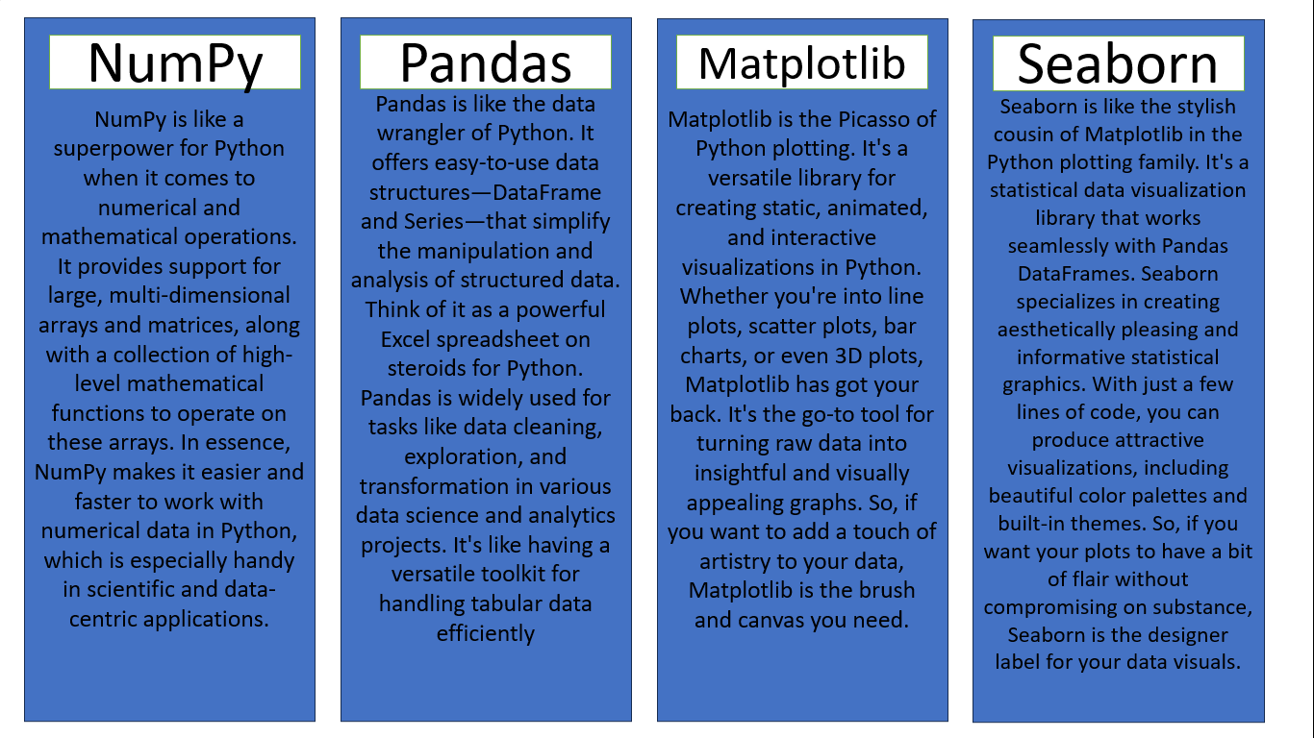

**OUTPUT:**

**VOLUME:**

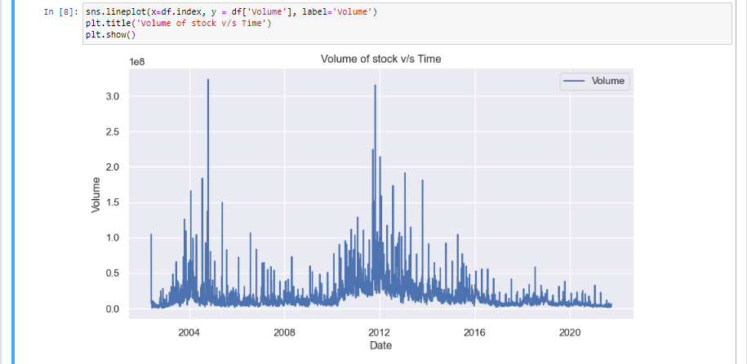

**Netflix Stock Price- High, Open, Close:**

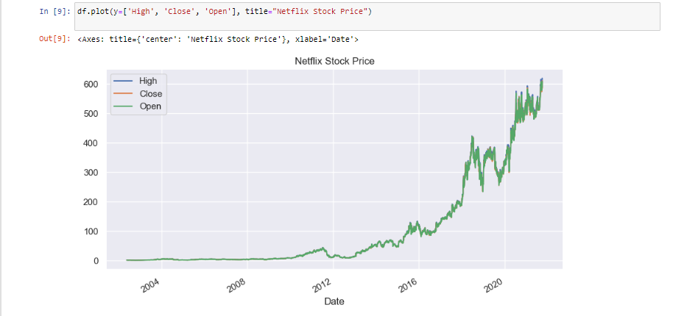

**Netflix Stock Price- Day, Month, Year Wise.**

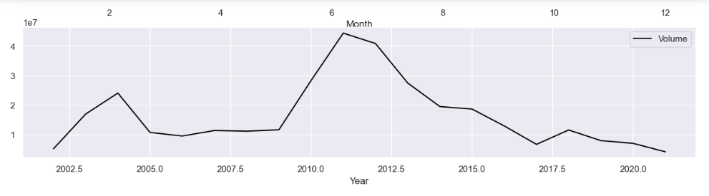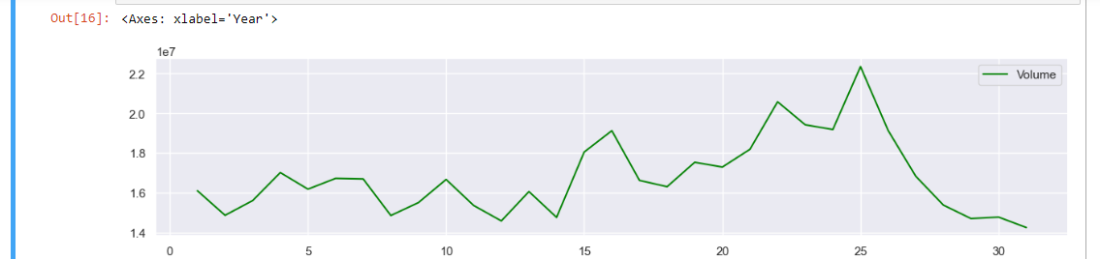

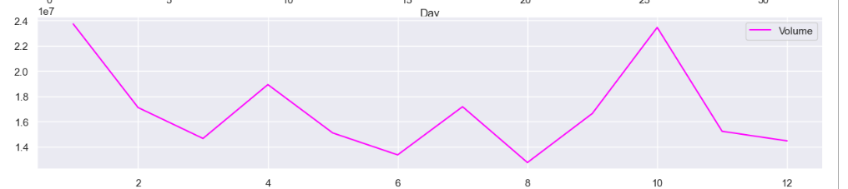

**Top-5 Dates with Highest AND LOWEST Stock Price:**

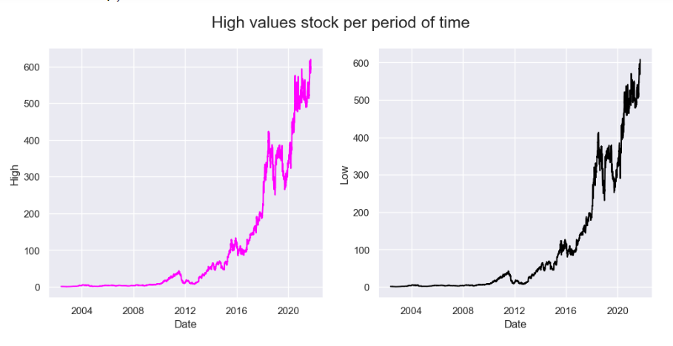

**References**

* [1] Wei D, "Prediction of Stock Price Based on LSTM Neural Network," 2019 International Conference on Artificial Intelligence and Advanced Manufacturing (AIAM), 2019, pp. 544-547, doi: 10.1109/AIAM48774.2019.00113
* [2] Ding, G., Qin, L. Study on the prediction of stock price based on the associated network model of LSTM. Int. J. Mach. Learn. & Cyber. 11, 1307–1317 (2020). https://doi.org/10.1007/s13042-019-01041-1
* [3] Selvin S., Vinayakumar R., Gopalakrishnan E. A.,Menon V. K. and Soman K. P., "Stock price prediction using LSTM, RNN and CNN-sliding window model," 2017 International Conference on Advances in Computing, Communications and Informatics (ICACCI), 2017, pp. 1643-1647, doi: 10.1109/ICACCI.2017.8126078.
* [4] Marchai F. L., Martin W. and Suhartono D., "Stock Prices Prediction Using Machine Learning," 2021 8th International Conference on Information Technology, Computer and Electrical Engineering (ICITACEE), 2021, pp. 79-84, doi: 10.1109/ICITACEE53184.2021.9617222.
* [5] Sandhya P., Bandi R. and Himabindu D. D., "Stock Price Prediction using Recurrent Neural Network and LSTM," 2022 6th International Conference on Computing Methodologies and Communication (ICCMC), 2022, pp. 1723-1728, doi: 10.1109/ICCMC53470.2022.9753764.